For this project, we need to get API key regularly because the provider has 24 hour limit refresh for each key

To start, please go to: <https://developer.riotgames.com/login>

And log in with the following info: project591 password Javaproject1

After login, please go to dashboard through the icon at the top right corner:

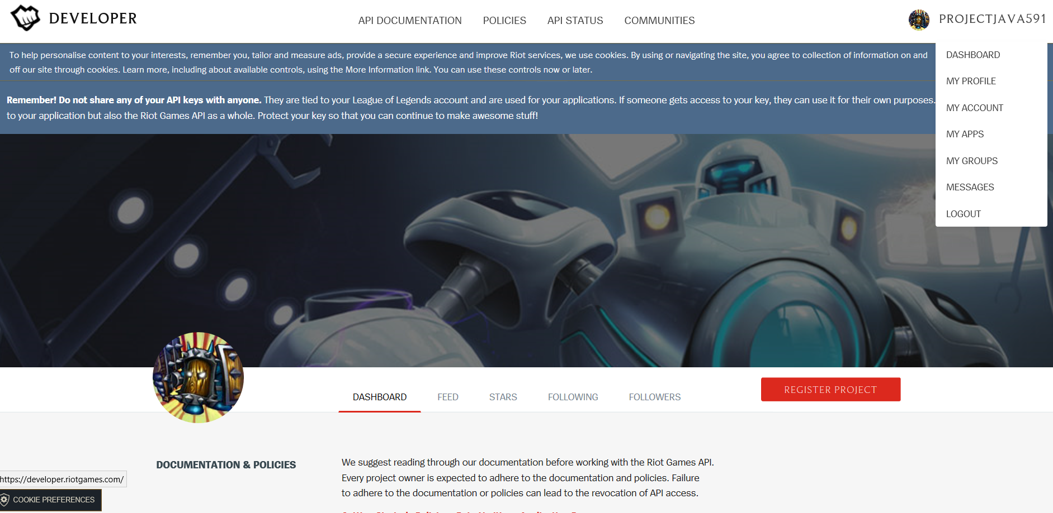

Scroll down and generate a new key:

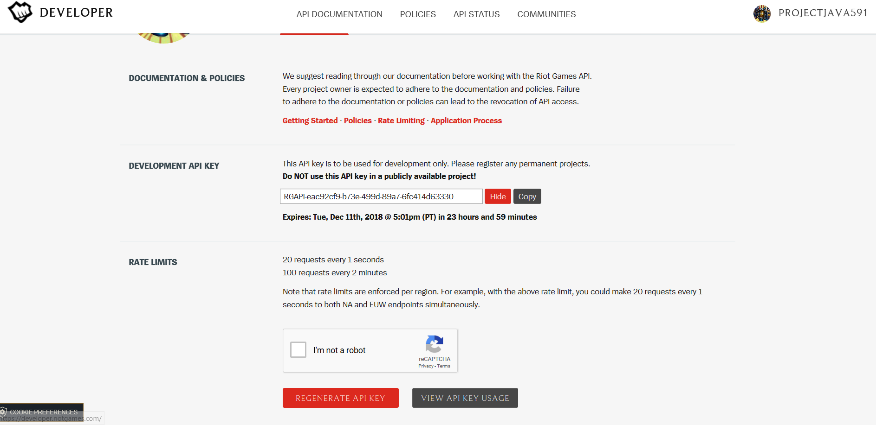

After obtaining the key, we can use for the project. The project has 3 functions as following:

* 1st Function Player statistics:
* Return analysis of the entered user
* Fill the API text box with obtained API
* Fill the username box with some user you want to run analysis on (suggested list: <http://na.op.gg/ranking/ladder/> ). The site takes different amount of games to analyze so there’ll be difference between the site and the program.

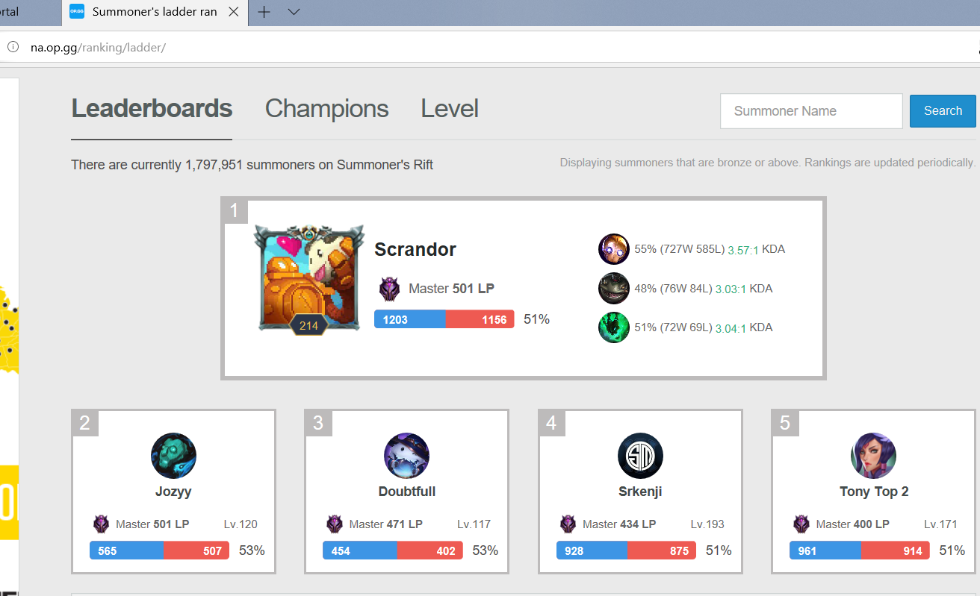

* We take Scrandor for username example:
* 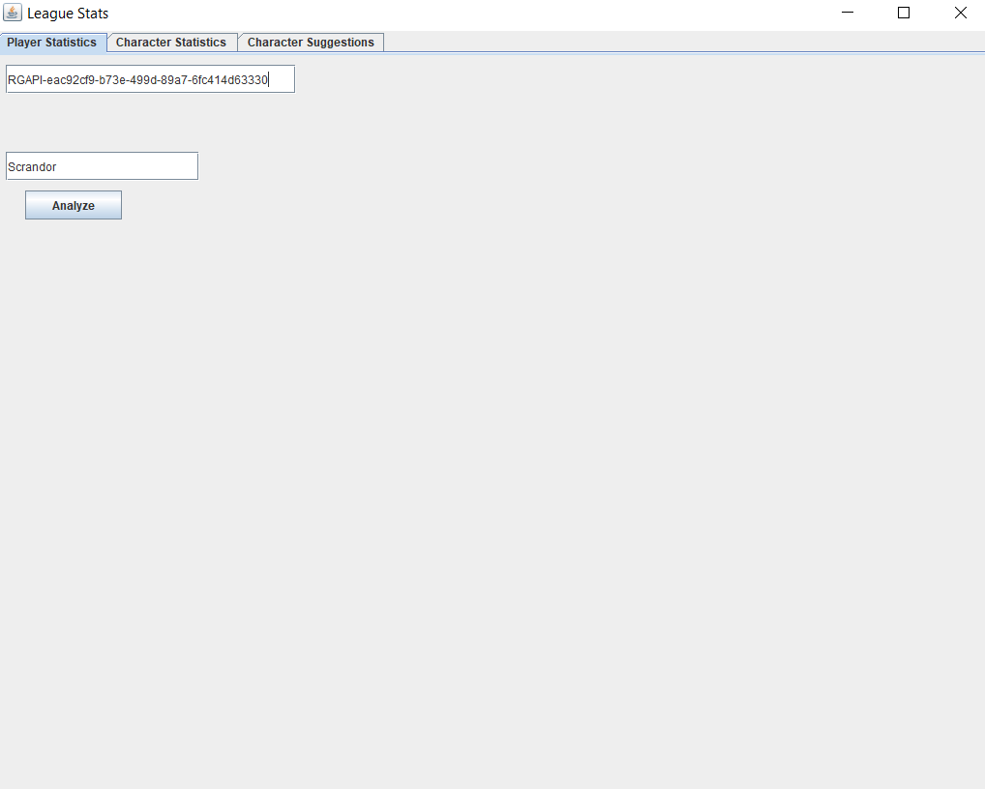
* Then we press Analyze and wait for the analysis to come up:

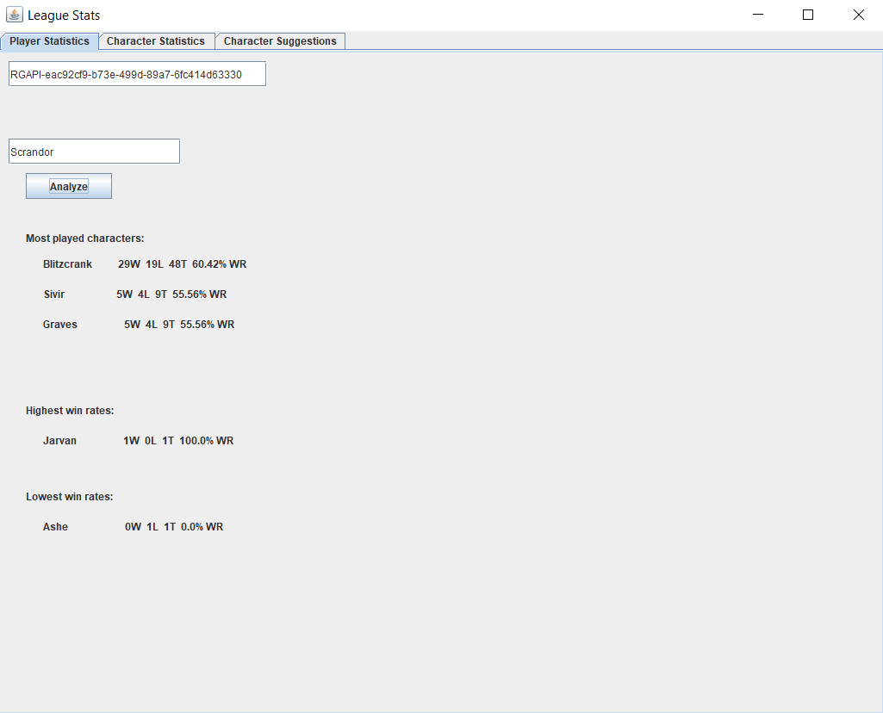

* The program needs to get match data slowly because the API limit from the provider. The function can only work once every 2 min due to API limit.
* 2nd Function: Character statistics:
* Generate what are the best (highest win rate) characters to play right now?
* Click on the button Generate highest win rate character and the data will come up.

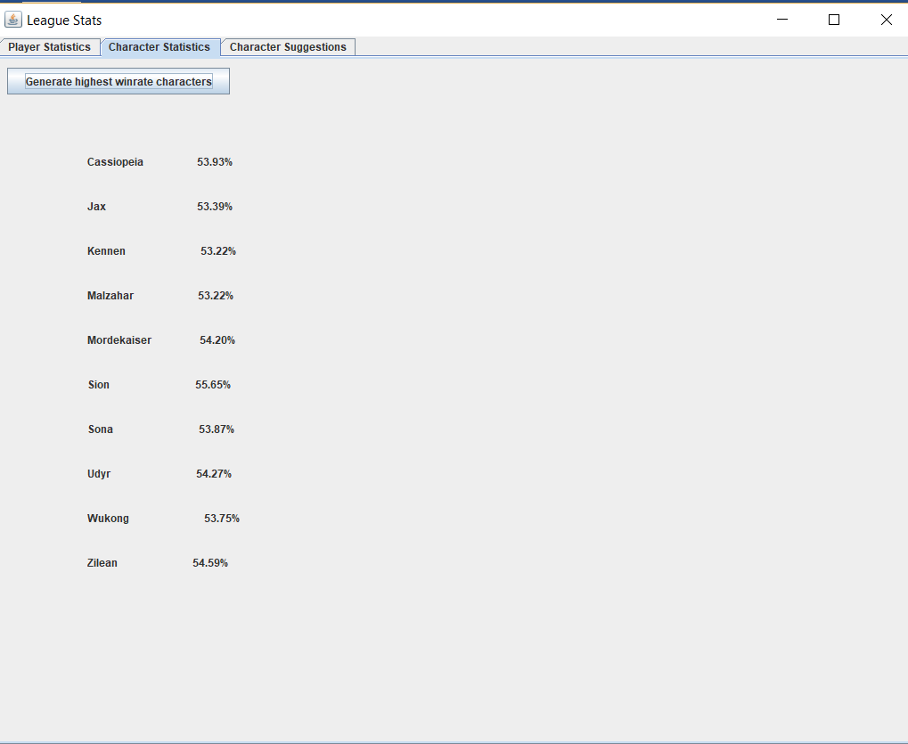

* 3rd Function: Suggest characters to play that fit user’s preferences:
* Answer the short questionnaire and press Submit, the list of character fitting that questionnaire will come up.

